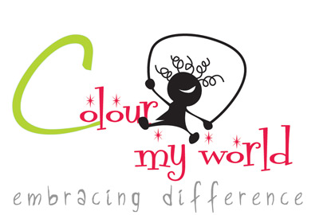
Registration Form
AUTISM AWARENESS CHARITY RUN/WALK

EVENT DETAILS

Date: Saturday, 22nd October 2011
Start Time: 8.30 am
Location: Independence Square
Entry Fee: Rs.500.00
Fund Raising: Registered individuals also have the option of fund raising on our behalf. The minimum amount that could be raised is Rs.1000 per person.
Course: The charity run/walk will begin and end at the Independence Square. It is a 3mile route. Water and first aid will be available.
Post-Race: There will be refreshments for all participants and prizes for the first two places.

REGISTRATION

Registration Period: Monday, 12th September 2011 to Thursday, 20th October 2011

Please give us a call so we could direct you to our nearest available location to hand over the completed form.
1). Fahmy Rahman: +94 776 531 499
2). Giselle Dass: +94 777 040 125

Visit us on Facebook: https://www.facebook.com/pages/Autism-Awareness-Charity-RunWalk/228768223840507

**Please be present by 8.00am on the day of the event for collection of numbers and t-shirts etc. Kindly note that t-shirts are only guaranteed for registrations submitted by Wednesday, 12th of October 2011.

PARTICIPANT DETAILS

Surname: _______________________ First Name: __________________________

Address: _______________________________________________________________

NIC/Passport Number: ______________________
DOB: ___/____/____ (DD/MM/YY) Gender:€ Male € Female

Tel: _______________________ Email: _________________________

I will be: Running € Walking €

T-shirt Size: Small € Medium € Large €

Waiver of Liability: In consideration of my entry being accepted, I waive any and all claims for myself, my administrators, and my heirs against all officials, sponsors, and organizations connected with this charity run/walk for injury or illness that may directly or indirectly result from my participation in this event. I attest that I have full knowledge of the risks involved in this event, and am physically fit, medically able and sufficiently trained to participate.
Furthermore, I confirm that all information provided above is completed truthfully and accurately to the best of my knowledge and I have not withheld any significant information. I am also aware that the registration fee paid is non-refundable in all case as all proceeds will be channeled to Charity.

I hereby declare that I have read, understood and agree to the conditions mentioned above.

Signature ________________________________ Date ___/___/___
Parent or legal guardian if under 16 years of age

Those who are not participating are welcome to come join in the fun and cheer on! There will be music and refreshment stalls for all to enjoy as well as an autism information stall if you wish to get more information and support.

Note: For the safety of all participants, strollers, skateboards and skates of any kind are prohibited in this event.

